Chapter 2 p.16

Distribution of top four attack progression notifications

Pie chart showing percentage of Distribution of top four attack progression notifications. It shows A. Successful identity attacks: 42%, B. Ransomware encounters: 29%, C. Successful targeted phishing attempts: 25%, and D. Business email compromise (BEC): 4%.

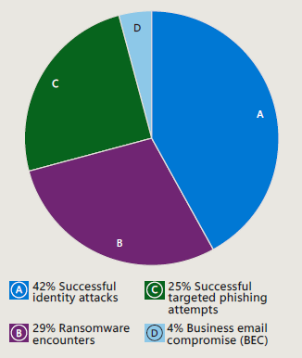

Telemetry sources: Microsoft Defender for Endpoint, Microsoft Defender for Cloud Apps, Microsoft Defender for Identity, Microsoft Defender for Office 365, Azure AD Identity Protection, Microsoft Defender Threat Intelligence